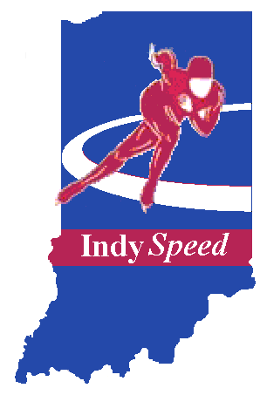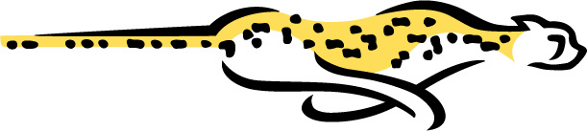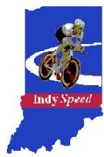
__________________________________________________________________________________________
IndySpeed Results Archive
__________________________________________________________________________________________

Event | 2016-2017 | 2017-2018 | 2018-2019 | 2019-2020 | 2020-2021 | 2021-2022
Wausau ST
Badger ST
Chicago Silver Skates | Results
Gold Cup | Protocol  Results
I-94 Sprints

Great Lakes ST
Holliday Classic | Protocol  Results
Junior ST Natz
LT Pettit TT | Results
Americas Cup ST
Park Ridge ST
Pittsburgh ST
Great Lakes LT
Midwest States LT
Mayor Daley
Land Of Lincoln | Protocol  Results
ST Louis Silver Skates | Results
LT Pack-style Natz | Men  Women
Masters International
Northbrook ST
Peoria ST | Results
Arnold Classic
IndySpeed Times | Results | Results

Event | 2002-2003 | 2003-2004 | 2004-2005 | 2005-2006 | 2006-2007 | 2007-2008
Wausau ST |  |  |  |  | Results | Results
Badger ST |  |  |  | Results | Men  Women
Chicago Silver Skates | Results | Results | Results | Results | Results | Results
Gold Cup | Protocol  Results | Results | Results | Results | Results | Results
I-94 Sprints |  | Results | Results | Results | Results | Results
Great Lakes ST |  | Results | Results | Results | Results | Results
Holliday Classic | Protocol  Results | Results | Results | Results | Results | Results
Junior ST Natz |  |  |  | Results | Protocol  Results | Results
LT Pettit TT | Results |  |  | Results | Results
Americas Cup ST |  |  |  | Results | Results
Park Ridge ST |  |  |  |  | Results | Results
Pittsburgh ST |  |  |  | Results | Results | Results
Great Lakes LT |  | Results | Results | Results | Protocol  Results | Results
Midwest States LT |  | Results | Results | Results | Results | Results
Mayor Daley |  | Results | Results | Results | A Results  B Results | Results
Land Of Lincoln | Protocol  Results | Results | Results | Results | Protocol  Results | Results
ST Louis Silver Skates | Results | Results | Results | Results | Results | Results
LT Pack-style Natz | Men  Women | Results | Results | Protocol  Results | Results | Results
Masters International |  |  |  | Protocol  Results |  | Results
Northbrook ST |  |  |  | Results | Results
Peoria ST | Results
Arnold Classic |  | Results | Results | Results | Results
IndySpeed Times | Results | Results | Results | Results | Results | Results

