AN INTRODUCTION TO SPEEDSKATING
IndySpeed
SAFETY EQUIPMENT FOR SPEEDSKATING
With the shorttrack racing season rapidly approaching, here is a quick summary of safety equipment available for skating.

For training sessions, all skaters must wear appropriate protective gear. This includes, but is not limited to:
Hard Shell Helmet
Gloves with leather palms
Long sleeves
Kneepads and shin guards are not required, but are recommended.
For competition, additional protective gear is required:
Helmet must meet speedskating safety guidelines (ISU / ASTM)
Neck guard
Knee pads
Shin guards
Helmets
Helmets are required to be the hard shell type, similar to bicycle helmets. For training, a bicycle style helmet is allowed. For competition, the rules state that a helmet cannot have any vent hole large enough for a speedskating blade to enter the helmet. This narrows the number of legal helmet brands to two models. These come in several colors. The IndySpeed club color is black.
Click on the link to view details.

1) The Mistral Helmet, made by LAS of Italy.
$93 from SpecialEquipment.com

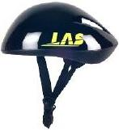

2) The Maple Speedskating Helmet,
$60 from SpecialEquipment.com

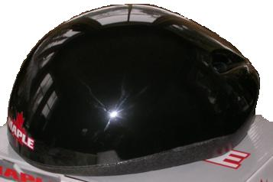

Neck Guards
Neck guards are required for short track competition, and are highly recommended for training.
Neck guards must also have a bib attached to protect the area below your Adams apple. There are two basic models of protector; models made from ballistic nylon, and models made from Kevlar.
Although slightly more expensive, most skaters prefer the feel of the Kevlar, as it is softer and more flexible. For your first competition, you can borrow neck protectors from the club.

1) Ballistic Nylon Protector, Itech N8
$24 from SpecialEquipment.com

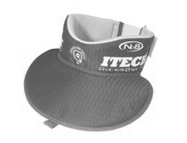
2) Kevlar Neck Protector, Itech NK22
$36 from SpecialEquipment.com
$25 from InlineWarehouse.com
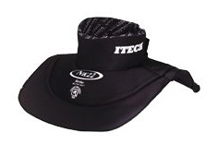

Kneepads
Kneepads are required for short track competition, and are highly recommended for training.
Inline or volleyball style pads are OK to use. The most popular model is made by “Trace”. They have an open back behind the knee, and are machine washable. Skating vendors sell these for $25 - $30.
The Club color on these is black.

Trace Knee Pads
$20 from SpecialEquipment.com


NeckGuards Built into Shirts
You can buy neck protectors built into a shirt. The Itech JP40 (youth) and JP400 (adult) are similar to “Under Armor” but with a Kevlar guard built into the collar.
http://www.dickssportinggoods.com/product/index.jsp?productId=2248069&cp=1786110
http://www.icewarehouse.com/descpage.html?pcode=JP40
http://www.icewarehouse.com/viewlarge.html?PCODE=JP400
http://www.dickssportinggoods.com/product/index.jsp?productId=2248068&cp=1786110
The Itech JP450 has kevlar at the neck plus kevlar at the wrist
(wrist protection is not required for speedskating)
http://www.inlinewarehouse.com/descpage.html?pcode=JP450

Itech JP400 with Kevlar Neck Guard Itech JP450 with Kevlar at Neck & Wrists

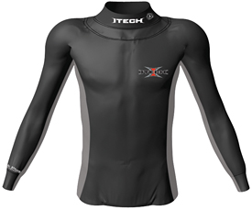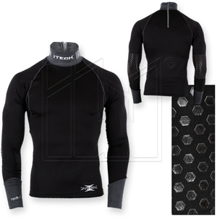

Shin guards
Shin guards are required for short track competition, and are highly recommended for training.
Simple soccer shin guards will work. You can find these everywhere for around $5. Do NOT buy the soccer guards that look like tube socks with ankle protectors. They will interfere with the fit of the boot around your ankle. The next level up is a Kevlar tube, and above that, Dyneema makes a Kevlar guard with the kneepads attached.

1) Standard shin guards 2) Kevlar Tube 3) Combo Kevlar tube and Kneepad
$5 - 10 anywhere $25 From SpecialEquipment.com $65 from DimonSports.com

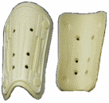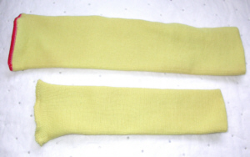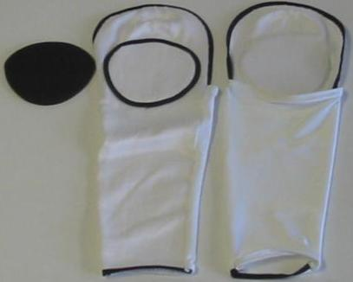

Kneepads and shin guards can also be sewn into a skinsuit. The custom clothing company called
Ice Beams (http://www.icebeams.com/ ), in Columbus, Ohio can sew machine-washable pads and kevlar guards into your skinsuit for around $50.
Gloves
Gloves are required for short track competition, and are also required for training. They need to have leather, at least on the palms, or Kevlar. The most popular gloves are very lightweight, similar to a baseball batting glove, or a racquetball glove. For a little more warmth, something like a competitive cross country ski glove can be worn.

Ultimate Safety
For the ultimate in safety and protection,
Elite skaters wear Kevlar long underwear.

To be worn under your skinsuit, these protect-ive suits have Kevlar in strategic locations attached to soft Lycra to insure a comfortable fit.

Bont’s version on left, sells for around $320
available from Bont.com

Made by Dyneema, and available for around $250 at SpecialEquipment.com

CONTACTS
we can be contacted at our website:
http://www.indyspeed.org/

Ken & Cindi Hart
Coaches, Indy Speed
KenBHart@aol.com

